**Assignment:**

**Installing XAMPP and Creating Database using phpMyAdmin**

**Step 1: Install XAMPP**

1. **Download XAMPP**: Go to the [XAMPP website](https://www.apachefriends.org/index.html) and download the installer for your operating system.
2. **Run the Installer**: Follow the installation instructions. Make sure to install Apache and MySQL components.

**Step 2: Start XAMPP**

1. **Open the XAMPP Control Panel**:
   * Once installed, open the XAMPP Control Panel.
   * You will see options to start Apache and MySQL.

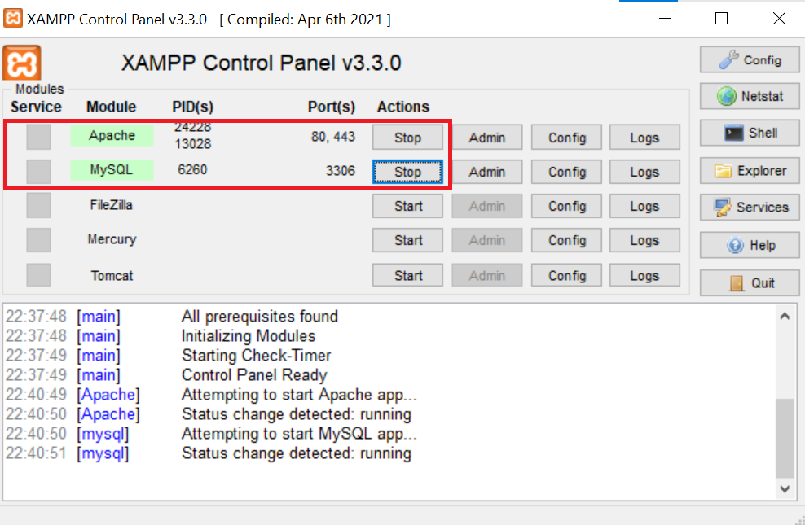

1. **Start Apache and MySQL**:
   * Click the "Start" buttons next to both Apache and MySQL.
   * If they start successfully, their status will change to green.



**Step 3: Access phpMyAdmin**

1. **Open a Web Browser**:
   * Type http://localhost/phpmyadmin in the address bar and hit Enter.
   * This will take you to the phpMyAdmin interface.

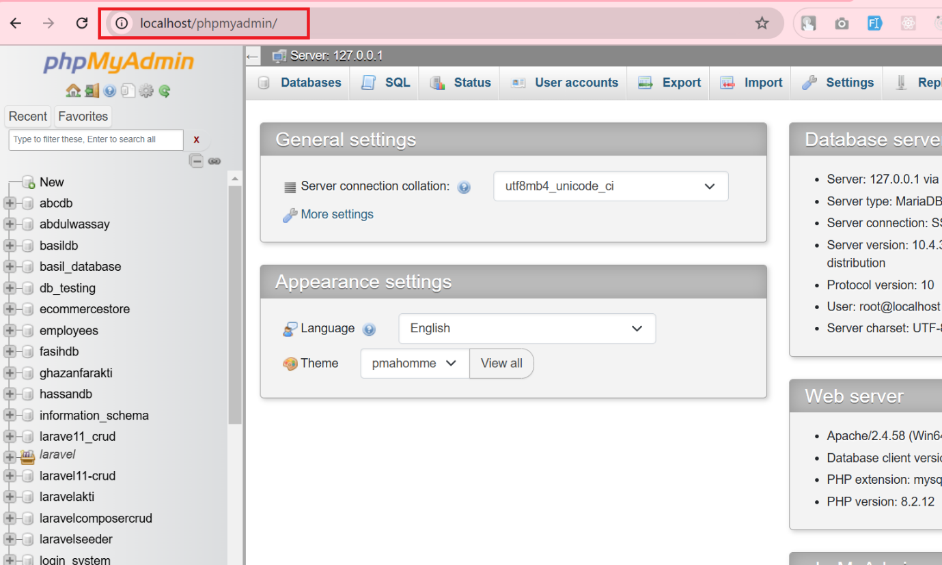

**Step 4: Create a New Database**

1. **Click on the "Databases" Tab**:
   * At the top of the phpMyAdmin page, click on the "Databases" tab.
   * You will see a field to create a new database.

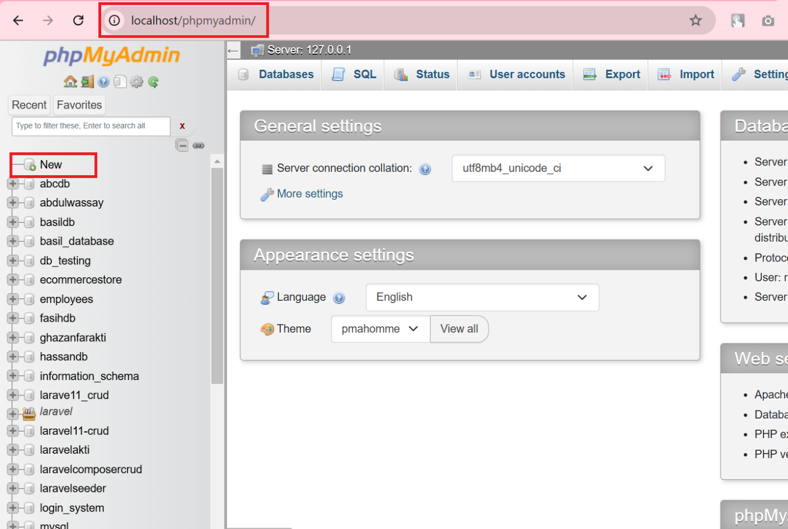

1. **Enter Database Name**:
   * In the "Create database" field, enter your desired database name (e.g., mydatabase).
   * Choose the collation (e.g., utf8_general_ci) if necessary.
2. **Click "Create"**:
   * After entering the name, click the "Create" button.
   * You should see a message saying that the database has been created successfully.

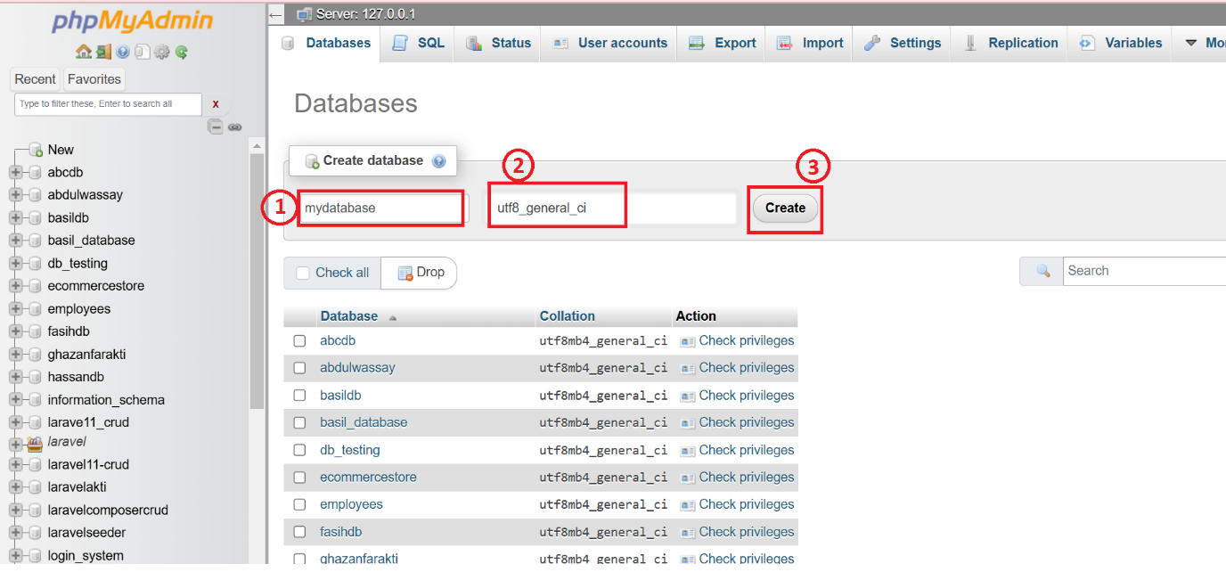

**Step 5: Create a Table in the Database**

1. **Select Your Database**:
   * Click on the name of your newly created database from the left sidebar.
2. **Create a Table**:
   * In the "Create table" section, enter the name of the table (e.g., users).
   * Specify the number of columns (e.g., 3) and click "Create".

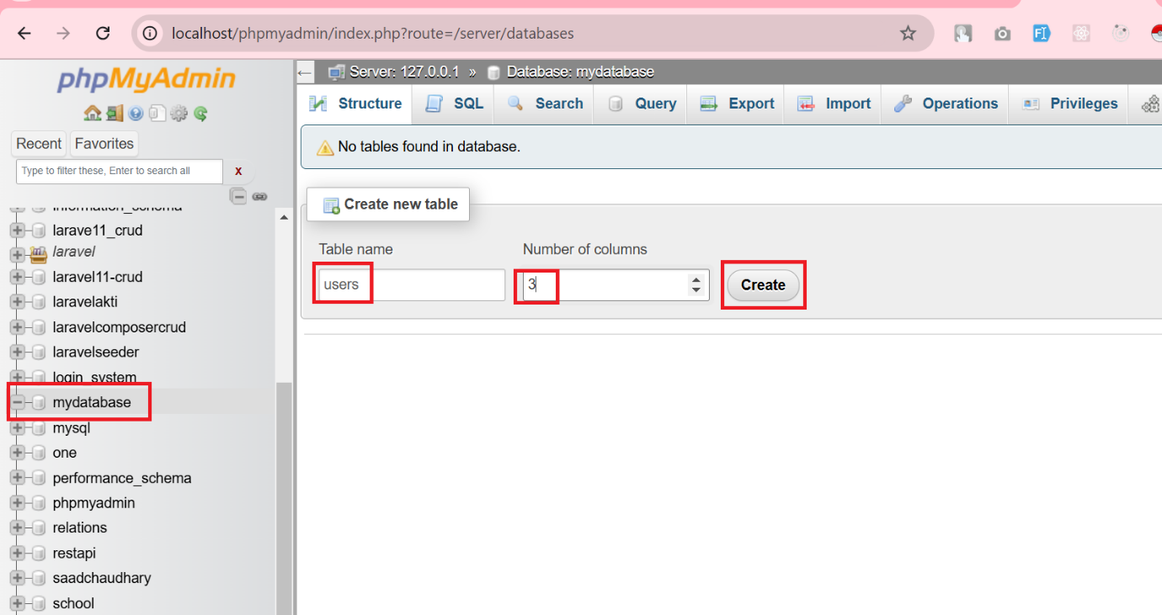

1. **Define Columns**:
   * For each column, enter the following information:
     + **Column Name**: e.g., id, username, email
     + **Type**: e.g., INT, VARCHAR, VARCHAR
     + **Length/Values**: e.g., 11 for INT, 100 for VARCHAR
     + **Index**: Set id as PRIMARY and check the A_I (Auto Increment) box.
2. **Click "Save"**:
   * After defining all columns, click the "Save" button.

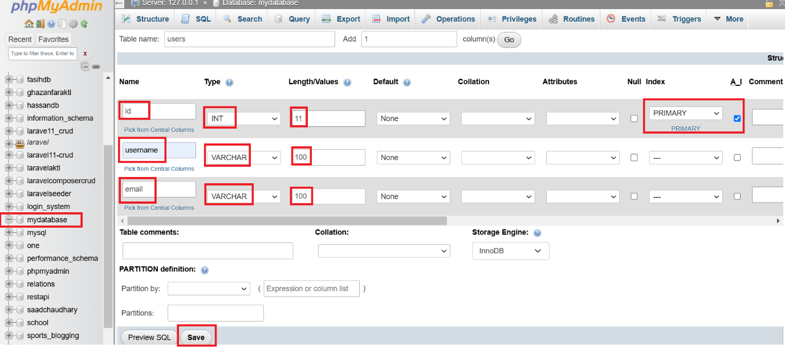

**Step 6: Insert Data into the Table**

1. **Select the Table**:
   * Click on the users table from the left sidebar.
2. **Insert Data**:
   * Click on the "Insert" tab.
   * Fill in the fields for username and email. The id will auto-increment.
3. **Click "Go"**:
   * After entering the data, click the "Go" button to save it.

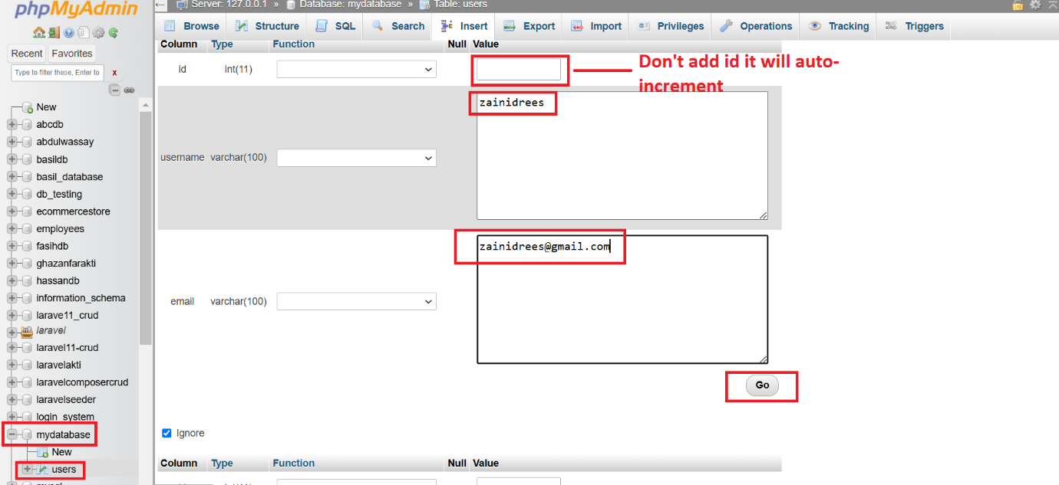

**Step 7: View Data**

1. **Select the Table Again**:
   * Click on the users table from the sidebar.
2. **Click on the "Browse" Tab**:
   * You will see the data you inserted displayed in a table format.

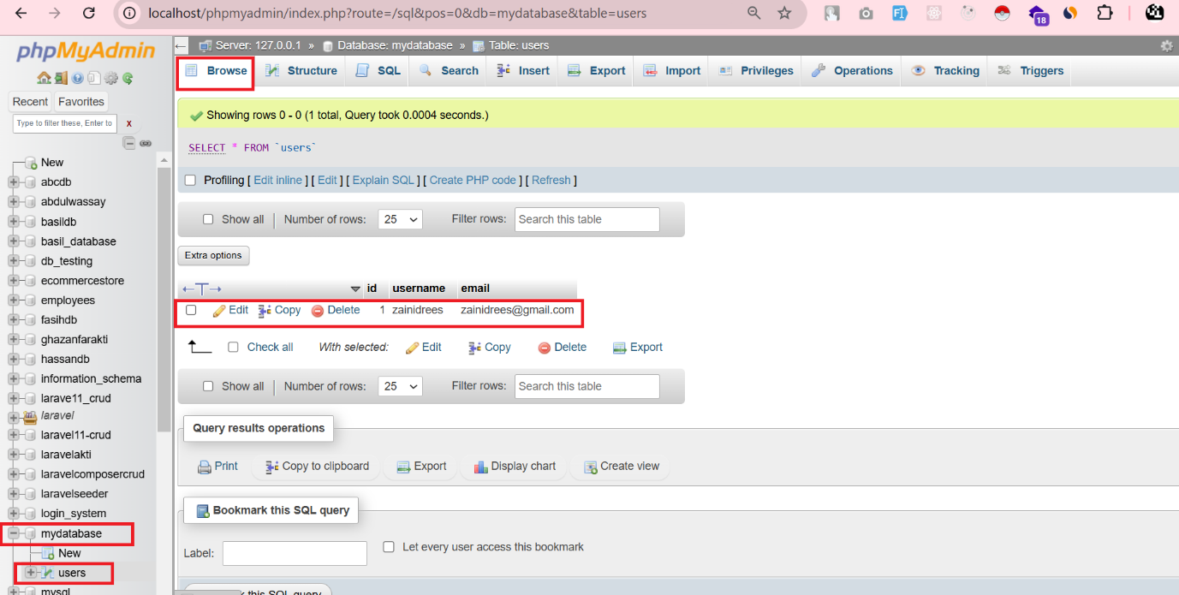

**Conclusion**

You have successfully created a database and a table in phpMyAdmin using XAMPP! You can now continue to add more tables, modify existing ones, or run SQL queries.

**Additional Tips**

* **Backup Your Database**: Use the "Export" feature in phpMyAdmin to back up your database.
* **Run SQL Queries**: Click on the "SQL" tab to run custom SQL commands.